**Module 3: Linux Administration**

**This module you will be able to:**

* Discuss system utility commands in Linux.
* Describe the different examples of system monitoring commands.
* Explain the root password recovery process.
* Outline the examples of standard text editors that are available on most Linux systems.

**Linux File Editor**

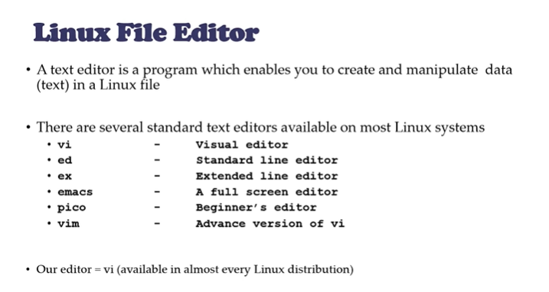

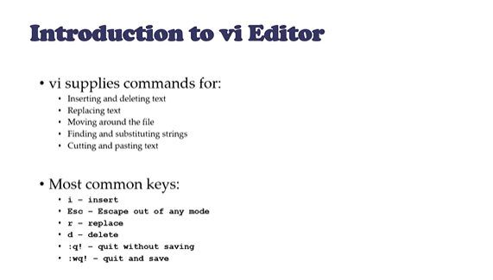

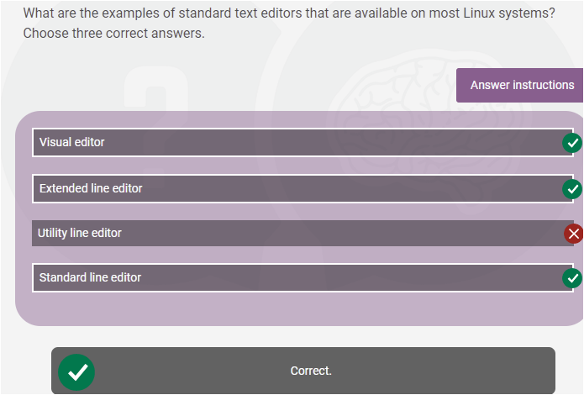

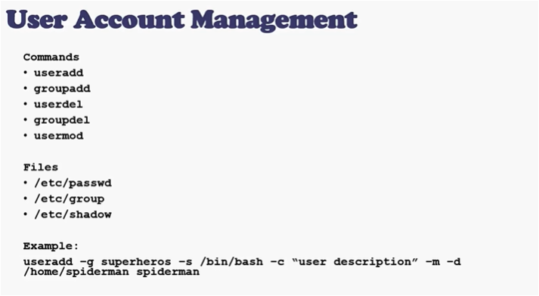**User account management**

**Make First C program on Linux**

sudo apt install build-essential

gedit sampleProgram.c

gcc [programName].c -o programName

./programName

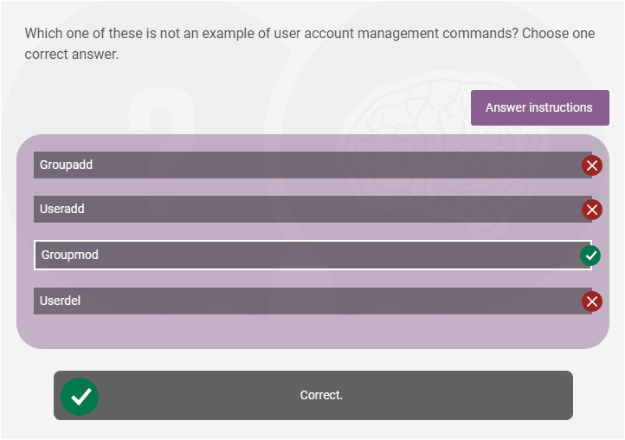<https://vitux.com/how-to-write-and-run-a-c-program-in-linux/>

**Switch users and sudo access**

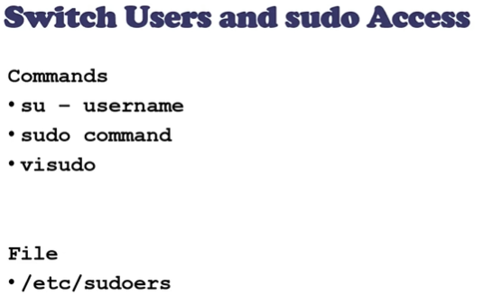

Sudo fdisk –l: to detect the disk consumption size.

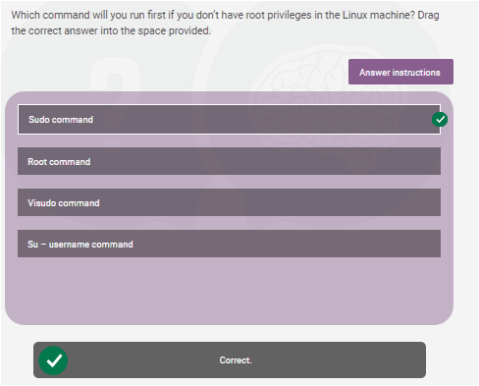

**System utility command**

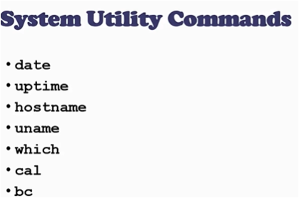



Cal:calender Bc:binary calculator

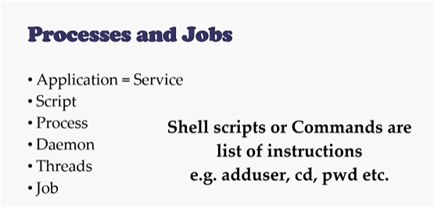**Process and jobs**

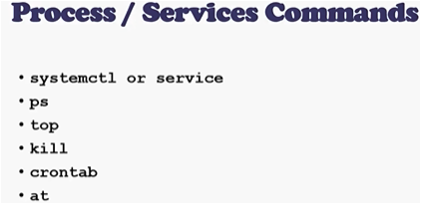

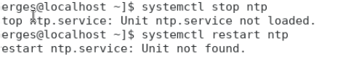

Top=Task manager in windows.

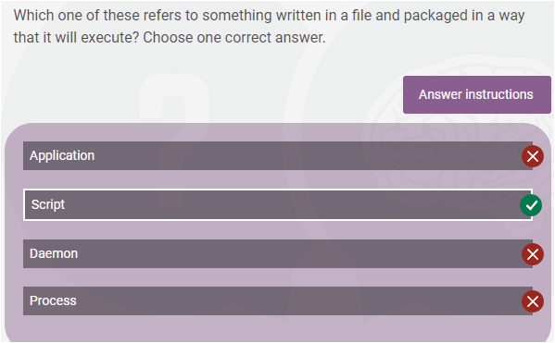Ntpd

**Process management**

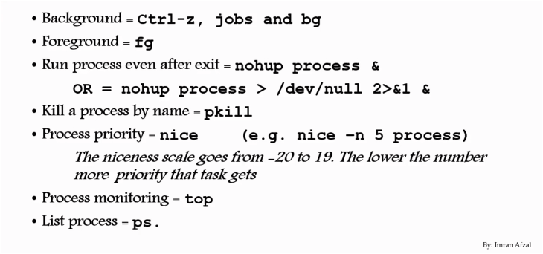

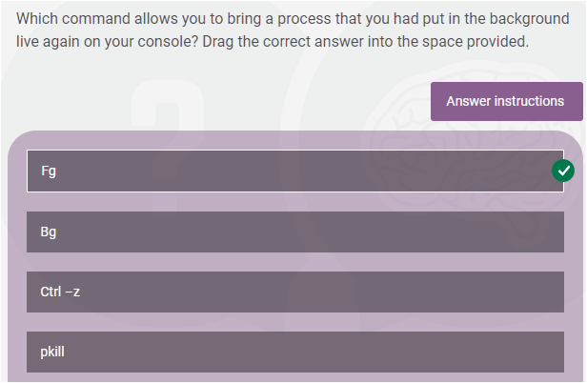

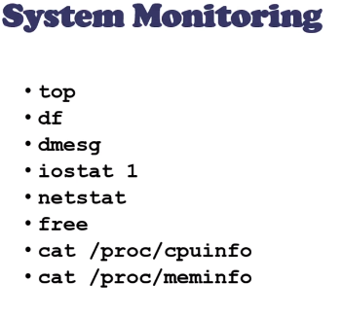**System monitoring commands**

Free: gives a physical memory.

Df : display information about file system disk.

Top: to show Linux process.

Dmesg: examine the kernel ring buffer and print the message .

**System Log monitoring**

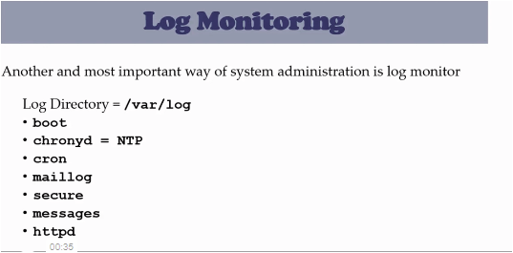Cron is a system that helps Linux users to schedule any task.

HTTPd stands for Hypertext Transfer Protocol daemon.

chronyd is a daemon process that runs in the background.

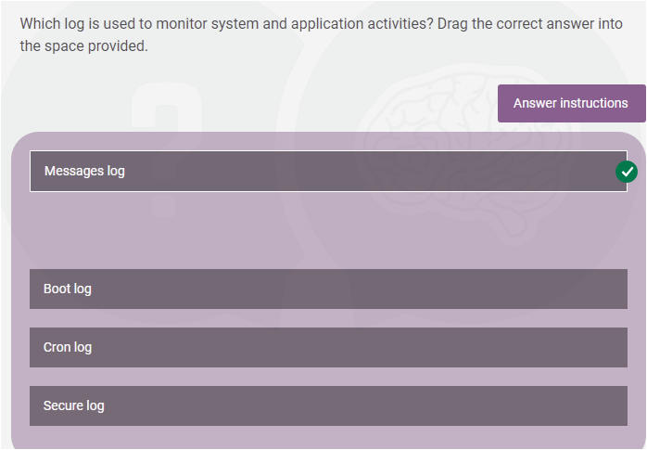

**System maintenance commands**